
Faculty of Applied Sciences
Bachelor of Science in Computing

COMP321 Information System Implementation
Final Report
Academic Year 2023/24
2nd semester

Online Shopping Mall
Group number: | 12
Group members: | Wai Kei Lap (P2104180)
 | Leong Chin Hou (P2104621)
 | Mak Cheok In (P2104308)
Lee Ling Yu
(P2104521)
Supervisor: | Andrew Sio
Assessor: | Philip Lei
Submission Date: | Apr 17, 2024

Table of Contents
1 Introduction 4
2 Requirements Analysis 5
2.1 Background 5
2.2 Related Work 5
2.3 User requirements 6
3 System Design 8
3.1 Architectural Design 8
3.2 Data Modelling 9
3.3 Dynamic Modelling 10
3.4 Accessibility 10
3.5 Product Recommendation 11
4 Project Outcome 12
4.1 Basic Functions 12
4.2 Accessibility 16
4.3 Product Recommendations 17
5 Software Quality 18
5.1 Software Verification and Security 18
5.2 Test Case 19
6 Project Management 21
6.1 Team Charter 21
6.2 Project Time Management 21
6.3 Project Risk Management 24
6.4 Job Distribution 24
7 Conclusion 26
7.1 Limitations and future works 26
References 27

Table of Figures
Figure 1: Entity Relationship Diagram 9
Figure 2: Activity Diagram for Customer 10
Figure 3: Activity Diagram for Vendor 10
Figure 4: Home Page 12
Figure 5: Product Details Page 13
Figure 6: Shopping Cart Page 13
Figure 7: Checkout Page 14
Figure 8: Purchase Order List & Detail Pages 14
Figure 9: Admin Dashboard Page 15
Figure 10: Home & Product Detail Page with i18n 16
Figure 11: Product Recommendations 17
Figure 12: Login interface 19
Figure 13: Register 19
Figure 14: Login 20
Figure 15: Order 20
Figure 16: PDM 23
Figure 17: Gantt Chart 23

Introduction
Nowadays, the internet has come to change everything regarding how we shop around. It is important to note that online shopping malls are among the key changes brought about by the digital revolution. With these virtual marketplaces, customers have found a simple way of trading in physical gyms where they can access thousands of products while at home.
We run an all-in-one sell site for electronics and other consumer goods. There are several areas on our website including wearable technology, computers, smartphones, and smart home appliances among others. By providing customers with accurate and up-to-date product information such as detailed descriptions, specifications, images, and reviews by our customers themselves can make a well-thought-out purchase. We take every possible measure to safeguard their financial data because we care for our esteemed consumers. Furthermore, people can sign in so that they can easily manage their orders by tracking shipments easily hence improving their overall shopping experience on this platform. Moreover, the platform is equipped with strong search filters which enable clients to quickly locate products based on prices or specific features among other things.
This is a summary of the subject: increasing online shopping malls, particularly those dealing with electronics. This shows how convenient and efficient e-commerce can be before it prepares ground for a discussion on its characteristics and benefits. Moreover, this beginning touches upon customer safety and satisfaction as well as detailed product information that assists customers in making correct purchase decisions. Generally, the introductory part is intended to draw readers’ attention to what is offered by this online mall.
This report is organized as follows: Chapter 2 explains system requirements. Chapter 3 shows how we designed it. Chapter 4 demonstrates our developed system. [and so on …]

Requirements Analysis
Requirements Analysis aims at identifying, understanding, and defining the requirements of the stakeholders for a system or project. This process is concerned with collecting information, analysing existing systems and processes as well as determining essential features, constraints, and goals of possible solutions.

Background
The world’s internet-based exchange system has grown in a big way lately, with firms and clients increasingly liking online sales. Statista puts the industry at about $4.28 trillion value in 2020 and estimates that it will reach $6.39 trillion by 2024. This increase shows how much one can do within e-commerce sphere.
Mobile commerce, or m-commerce, has become highly popular with the widespread adoption of smartphones. According to Statista, in 2021 mobile e-commerce accounted for 54% of all e-commerce sales. This shows that having a website and an app that is easily navigable from smartphones is important because many customers prefer shopping on their phones.
For an e-commerce platform to be efficient there must be effective product catalog management. Such management must enable one to manage and show many products besides implementing such options as categorization, filtering and sorting in order to help customer locate what they need promptly.
Effective order management and tracking systems are among essential features for any successful e-commerce platform. The clients should have easy access to their orders, keep track of shipment status and receive prompt notifications concerning any changes in their orders. Consequently, a seamless and transparent purchasing process can be achieved.
The customer’s shopping experience can be significantly improved by personalization and recommendation engines. Customer engagement and satisfaction can be increased through personalized recommendations, which are derived from user preferences, purchase history and browsing behaviour implemented in e-commerce platforms. A sense of belonging to a group of people who share similar lifestyles is fostered with customer loyalty leading to higher conversation rate.
To sum up, the global e-commerce market is still expanding because of consumer habits and mobile commerce. For them to succeed in this competitive environment, efficient product catalog management, order management/tracking should take precedence over other things such as personalization and recommendation engines for e-commerce platforms that are still adequate to serve customers. This way, enterprises will take advantage of the growth opportunities presented by the larger e-commerce market and avail an enjoyable seamless shopping process for their clients.

Related Work
For an online shopping mall to be successful, conducting market research on existing platforms is essential. Amazon, eBay, Alibaba and Taobao are examples of winning business models that the business can borrow from concerning their business models, user interface elements as well as consumer engagement methods.
Product classification, seller management, customer feedback, and recommendation algorithms are all subject to analysis. This study also allows us to discover best practices and areas for improvement. This analysis can lead to the development of a more comprehensive product catalog management system, as well as an improved understanding of customer creation, order management, and tailored recommendation engines.
There is also a need to review the existing research on user experience and other publications done on online shopping malls such as Taobao, Amazon and Pinduoduo which can provide insights about how consumers behave, what makes them insatisfied and the best possible designs for interfaces. It must be able to guide on navigation techniques, give effective product search platforms plus several checkout options.
Making linkages between existing online shopping malls and user experience research can help organizations create platforms that satisfy customer expectations and deliver a shopping experience. This method ensures that the platform under development satisfies the needs and expectations of its users.

User requirements
- Customers may register a new account. They have to provide full name, email address, password and shipping address in registration.
- The product search and product detail information are accessible to customers before login. After login, customers can, in addition, manage their shopping carts and orders. Shopping cart content, purchase orders and other customer information are stored in the server side and are persisted across user sessions.
- Customers may browse numerous products in a list (or grid, if appropriate). This product list shows basic information of products, including product name, price and a thumbnail image.
- A customer can search products by product name (and optionally other product attributes). The search result is shown in a list.
- Customers are provided suitable controls for navigating a long product list. For example, desktop interfaces typically support pagination, while mobile interfaces usually employ infinite scroll or a ‘load more’ button.
- Customers may click/tap a product in the product list to view product detail information, which includes two more attributes in addition to the product name, price and a thumbnail image.
- Customers can add a product to their shopping carts. The default quantity to buy is 1.
- Customers can list the products in their shopping carts, showing the product name, price and quantity to buy. The total order amount (i.e. how much the customer has to pay in total) in a shopping cart is also shown. A customer can click/tap an item in the shopping cart to review the product detail.
- Customers can change the quantity to buy for a product in the shopping carts, if it makes sense for the kind of products sold in the e-commerce system.
- Customers can remove a product from their shopping carts.
- Customers can check out all items in the shopping cart. This action creates a purchase order and clears the content of the cart.
- Customers can list the purchase orders that they have placed. The following is shown for each purchase order: the P.O. number, the purchase date, the total order amount and the purchase order status. The purchase orders are displayed in reverse chronological order of purchase date. When a customer clicks/taps an entry in the list, they can see the detail of the purchase order.
- The detail of a purchase order to show includes the P.O. number, the purchase date, the shipping address, the total order amount and the purchase order status. For each product in the purchase order, the product name, the quantity, the unit price and the subtotal are displayed.
- The vendor can browse the products in the product catalog, and search products by product name (and optionally other product attributes).
- A system-generated unique product ID is also shown. The vendor can search products by entering a substring of the product ID.
- The vendor may add a new product to the catalog. The vendor enters detail information of the product, which includes, but is not limited to, the product name, price and a thumbnail image.
- The vendor can edit product detail information.
- The vendor can disable a product to temporarily hide it from customers in the store front. The vendor can later enable the product.
- The vendor can list the purchase orders placed by customers. The purchase orders are sorted in descending order of purchase date (i.e. newest first). The list shows the P.O. numbers, purchase dates, customer names, total order amounts and purchase order status.
- The vendor can click/tap a purchase order to show its detail and line items.
- The e-commerce system supports multiple photos per product. The store front displays the photos in product detail, and the administration portal allows adding and removing photos from a product. (Optional: some products may use a short video in addition to photos.)
- The e-commerce system supports basic order processing. An order status is maintained for each purchase order to track the order processing workflow. You can define your own order status workflow, which contains at least four possible values for order status. The store front and the administration portal allow the customers or vendors to carry out actions that trigger order status change. For tangible products: pending (a customer just places an order), shipped (the vendor ships a pending order), cancelled (a customer cancels a pending order before it is shipped) and hold (the vendor cannot ship the order for some reasons, and need to revise the order). The vendor can ship a hold order later after resolving some issues. The customer can also cancel a hold order.
- Customers can filter the list of purchase orders by order status.
- The system keeps record of the date for some changes of order status, and displays these dates together with other order detail information. Example includes shipment date and cancel date.
- Accessibility is important for individuals, businesses, society in order to provide equal access and equal opportunity to people with diverse abilities. The common requirement in making web applications accessible to wider audience is internationalization. Internationalization, sometimes referenced as i18n, is the process of designing and preparing your software products for use in different locales around the world. Examples of such process include text translation into different languages, formatting date and time according to specific locale, etc. Businesses can no longer afford to limit content to their default language. Internationalization considerations enable users to interact with the software in their native mother tongue, which improves the user experience and overall diversity, inclusion, and accessibility of the software. In addition, with internationalization, new customers and markets become available.
- Simplifying product discovery for customers is a huge advantage. The recommended products can increase the chance that a customer will find relevant products, which can lead to increased sales. Product recommendation seeks to predict and show the items that a user might like to purchase. Examples of recommendation strategies can be based on products that are commonly purchased together, have a similar product description, being best-sellers, frequently purchased, etc.

System Design
This chapter focuses on designing a system that satisfies the needs and considerations outlined in the previous chapter. The design process typically begins with high-level designs, which are closer to the business data and features exposed to users. The system design purpose of this project is to build a web application using the Django framework. The goal of system design is to create a reliable, efficient, and easy-to-maintain application that meets user needs and provides a good user experience.

Architectural Design
The system can be described as a three-tier architecture with the high-level architectural plan. In this model, user interaction and interface presentation are done by the browser-side while business logic is handled by the server-side and responds to requests while data manipulation is done by the database system.
In browser-side, this is the highest level of the application. The presentation tier exposes the application to users. It has a direct interaction with users and routes user requests to Backend. In this case, it’s handled by the browser, running HTML, CSS, and JavaScript. Bootstrap, which is a frequently used Web UI framework for designing responsive and mobile-first websites.
In server-side, this is controlled by the server which processes user requests, manipulates data in memory and passing through it from Input/Output devices on computer on which database system resides which then stores this data in permanent storage on behalf of an authorized user. It’s built using Python with Django framework included there in its core package. Web Frameworks are used to facilitate rapid development of applications that are scalable and maintainable.
In database system, it is where data is stored and retrieved from when necessary. Data can be managed directly using SQLite database engine. It’s done through an SQLite C library which offers a small footprint disk-based database that doesn’t require separate server process. Some use nonstandard variant of SQL language as interface while others will use any kind of object-relational mapping libraries including those provided by the RDBMS vendors themselves. Some applications may choose to use SQLite for internal data storage only making it invisible to outside clients.
The development environment and tools used are as follows:
- Server-side programming language: Python (Django framework)
- File upload library: GitHub
- Web UI framework: Bootstrap
- Database system: SQLite
The selection of server-side programming languages was based on Python and Django as they are extensively simplified and easily readable because it is a great choice for server-side programming. Django, as one of the Python frameworks, shares these benefits and adds some others including fast development and simple pragmatic design.[1] As for the front end, Bootstrap was chosen because it has many components to choose from and it is responsive at the same time.[2] SQLite became a natural choice for databases because of its zero configuration, and serverless nature which makes it easy to handle.[3]

Data Modelling
Figure 1 shows the entity relationship diagram of the database of this project. The entity CUSTOMER represents a customer with a unique ID, full name, email, password, and shipping address, and a customer may have 1 or more orders. An order is represented by the entity ORDER. It includes a unique ID, customer name, ordered date, order status, shipping date, and cancel date, an order is only ordered by one customer and may have one or more order items. An order item is represented by the entity ORDERITEM. It includes a unique product ID, unique order ID, and item quality, an order item only includes one order and one product. A product is represented by the entity PRODUCT. It includes unique product ID, product name, product price, brand, connective technology, cover image, description, and active status, and a product may equal 1 or more order items and a product may have 1 or more images. A product is represented by the entity IMAGE. It includes a unique product ID and product image, and an image only has one product.

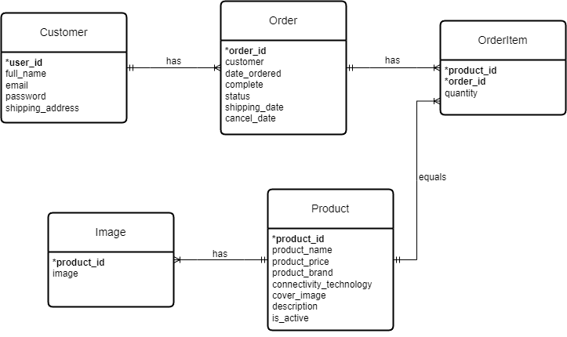
Figure 1: Entity Relationship Diagram
In this model, there are no direct many-to-many relationships. However, a many-to-many relationship can exist indirectly. For example, a CUSTOMER can order multiple PRODUCTS and a PRODUCT can be ordered by multiple CUSTOMERS. This is handled by introducing the ORDERITEM entity.
If the price of a product changes, it will affect the PRODUCT entity. The product price attribute in the PRODUCT entity would need to be updated. The rationale behind this design is to normalize the data and reduce redundancy. Each entity represents a distinct object in the system and the relationships between entities accurately reflect the business rules of the system.

Dynamic Modelling
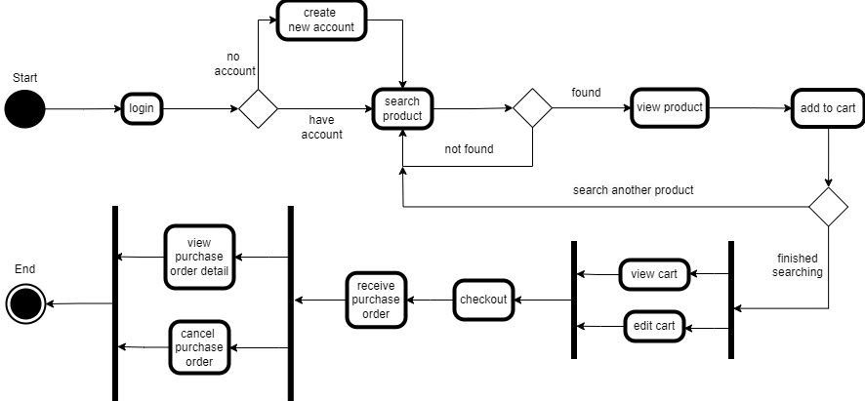
Figure 2: Activity Diagram for Customer
The above figure shows the actions of users registering, logging in, as well as searching for products, adding products to their shopping cart, editing the shopping cart, checkout to receive purchase orders, and viewing the purchase order detail interface.

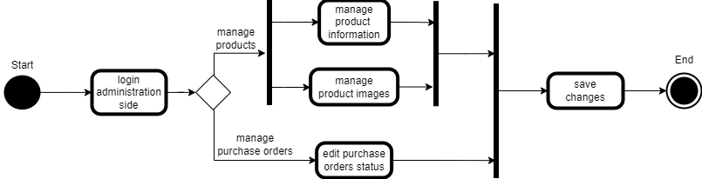
Figure 3: Activity Diagram for Vendor
The above figure shows the vendor's use of the administrator interface to manage all purchase orders, products, and their images, including product search, addition and deletion, information modification, order confirmation, and order status modification.

Accessibility
Accessibility is important for individuals, businesses, society in order to provide equal access and equal opportunity to people with diverse abilities. Internationalization, often shortened to “i18n”, is the practice of designing a system in such a way that it can easily be adapted for different target audiences, that may vary in region, language, or culture. The complementary process of adapting a system for a specific target audience is called Localization. Another common requirement in making web applications accessible to wider audience is internationalization.

Product Recommendation
Product recommendation is an indicator of various products that are suggested specifically to a buyer depending on their browsing history, purchase logs, preferences, and other pertinent data. In this way, product recommendations act as a virtual shopping assistant; they enable customers to discover goods that match their personal interests, desires, or fads. To achieve this goal algorithms utilized by product recommendation systems heavily depend on analyzing behavioural information. For example, approaches for recommendations can be built around related items that are often bought simultaneously with the one under consideration, possess similar characteristics in their description sections, become bestsellers upon release or generally bought by many buyers among other scenarios.

Project Outcome
The implementation of an information system provides a good description of project outcome. These consequences can be either physical or otherwise in nature, such as technical ones, day-to-day operations results, and strategic accomplishments. A successful project includes the installation, configuration as well as customization of the system in addition to streamlining process flows within the enterprise itself which have resulted in increased productivity levels and further contributed towards decision-making enhancements. Moreover, this project outcome also emphasizes on change management and training programs which are used by staff members for their acceptance or adoption of the new system at company level. Finally, moving forward with this project outcome sets pace for improving future projects.

Basic Functions
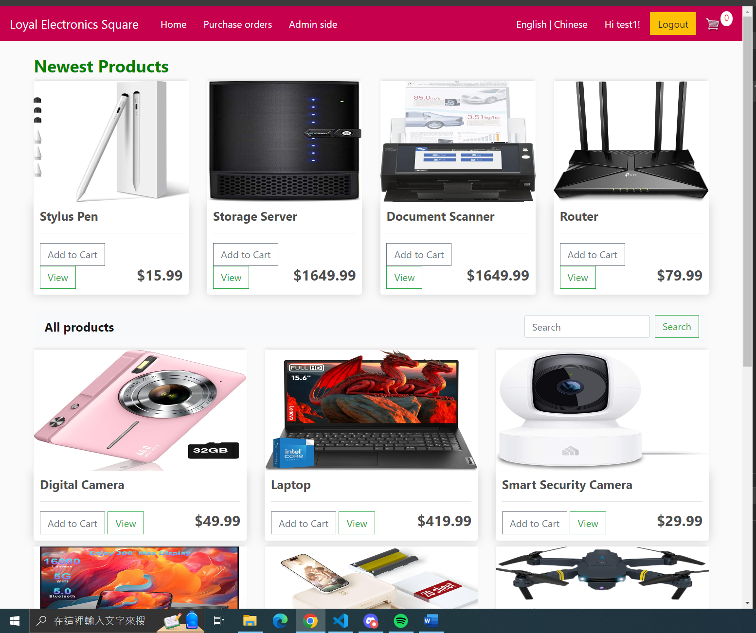
Figure 4: Home Page
The picture above is the main page of this project, and this page lists all the products. For the blue circle, there are lists of other links such as purchase orders and admin side pages. For the black circle, there is a button for login and logout, and it will show the customer’s name, also there is a link for the go to the cart page, and there is a number for counting product quantities in the cart. For the orange circle, there is a search bar for customers to search for products with product names. In the red square, there are shown the product's basic information, such as product name, cover image, and price, also there are buttons for adding the products to the cart and viewing more about the product details.

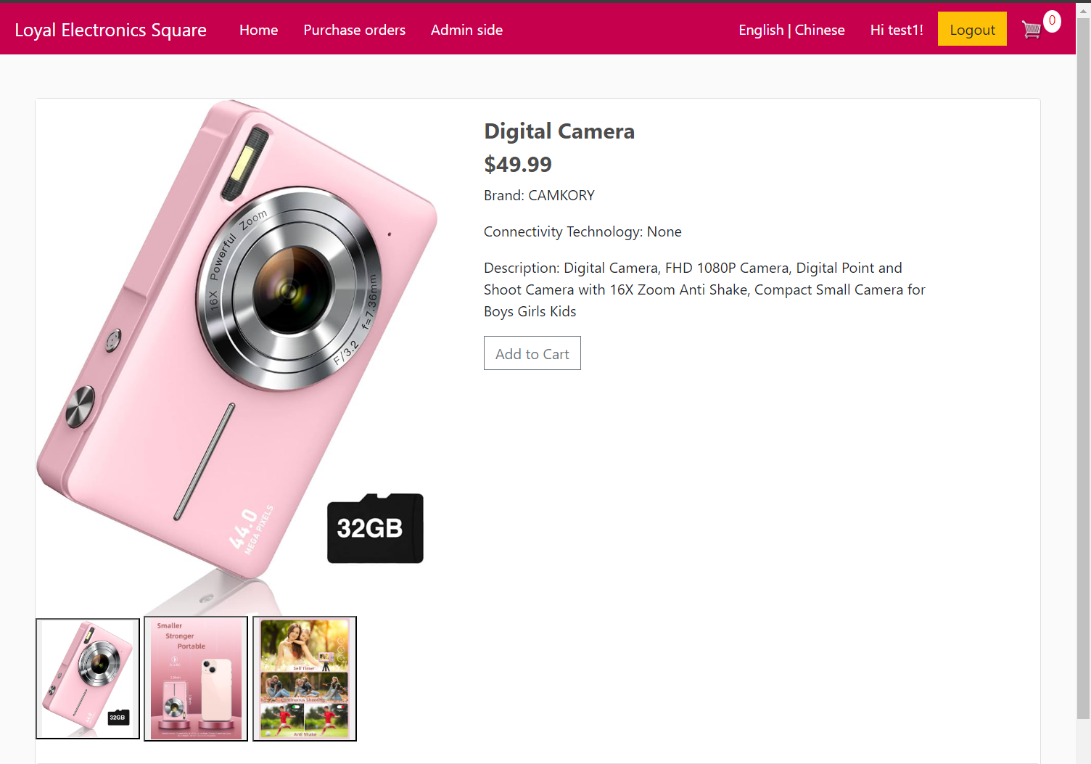
Figure 5: Product Details Page
The picture above is the product details of this project. On the red side, there are all the details about this product, and there is a button to add to the cart below the description. On the blue side, Customers can switch images to interested more about this product.

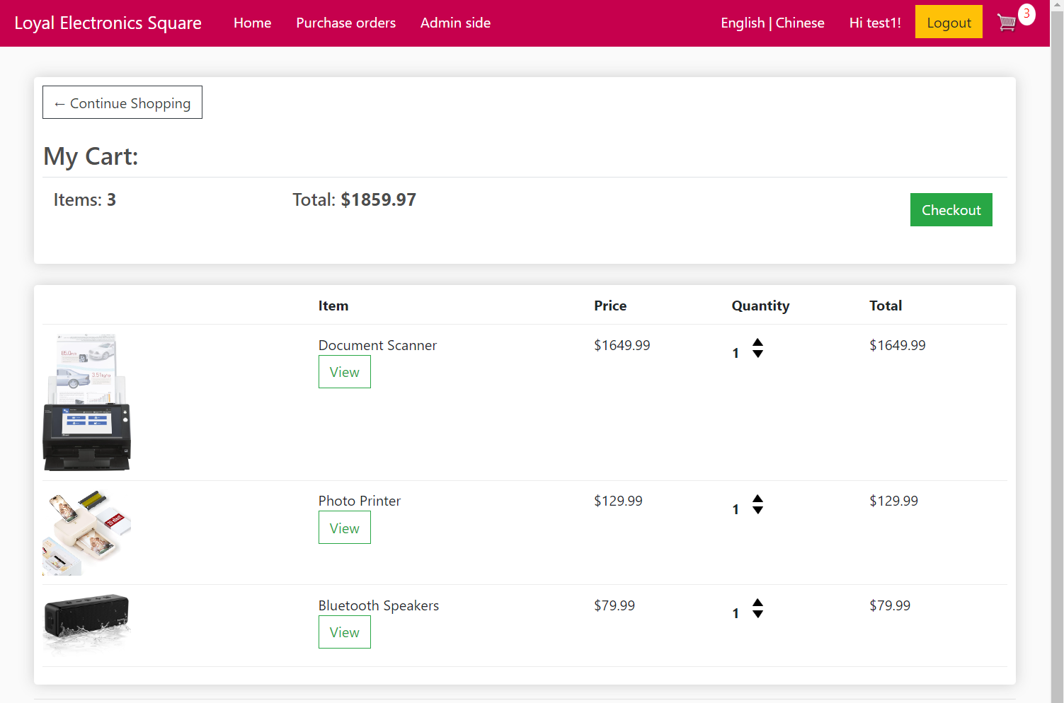
Figure 6: Shopping Cart Page
The picture above is the shopping cart of this project. On the red side, there are shown the total product items and total price in this cart. On the blue side, this button can be clicked on the checkout page to prepare to create a purchase order. On the green side, there are all the products and their details which the customer added them to the cart, also the up and down button can change the quality of the product, if the quantity is 0, the product will be deleted from the cart.

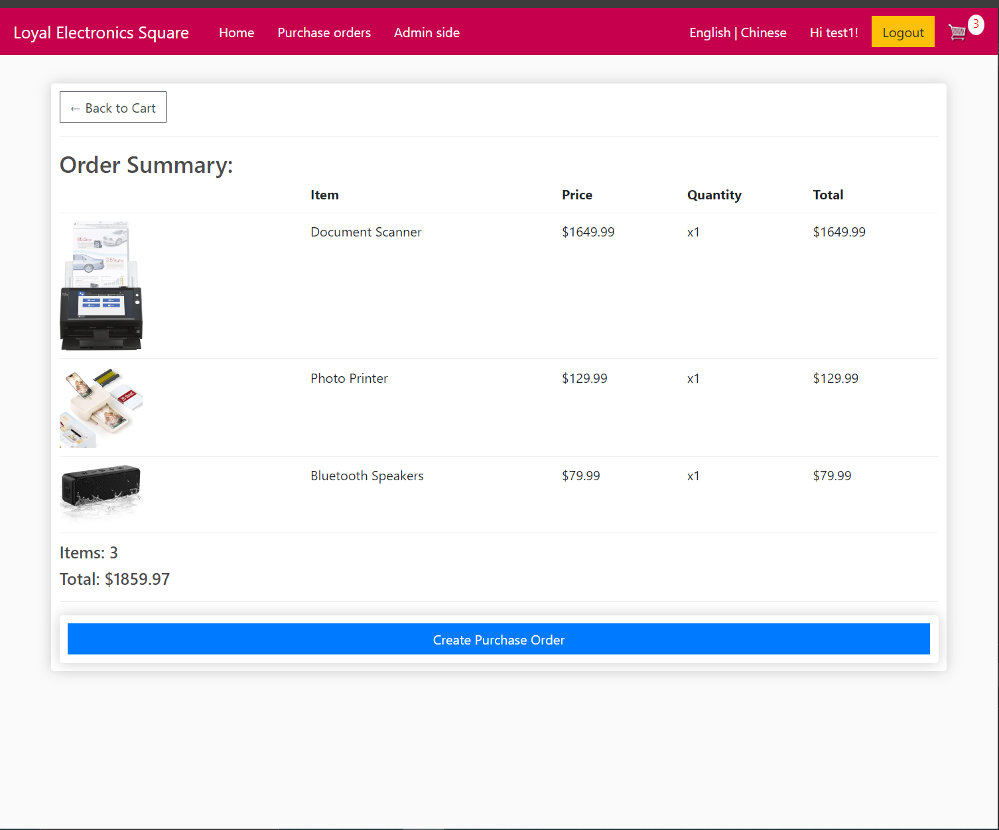
Figure 7: Checkout Page
The picture above is the checkout page of this project, this page is for the customer to confirm their order. On the red side, the customer clicks the button to create the purchase order.

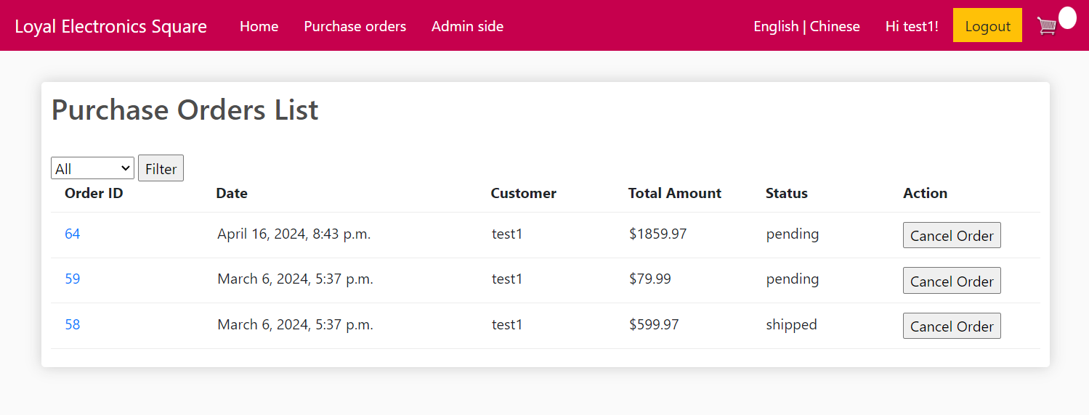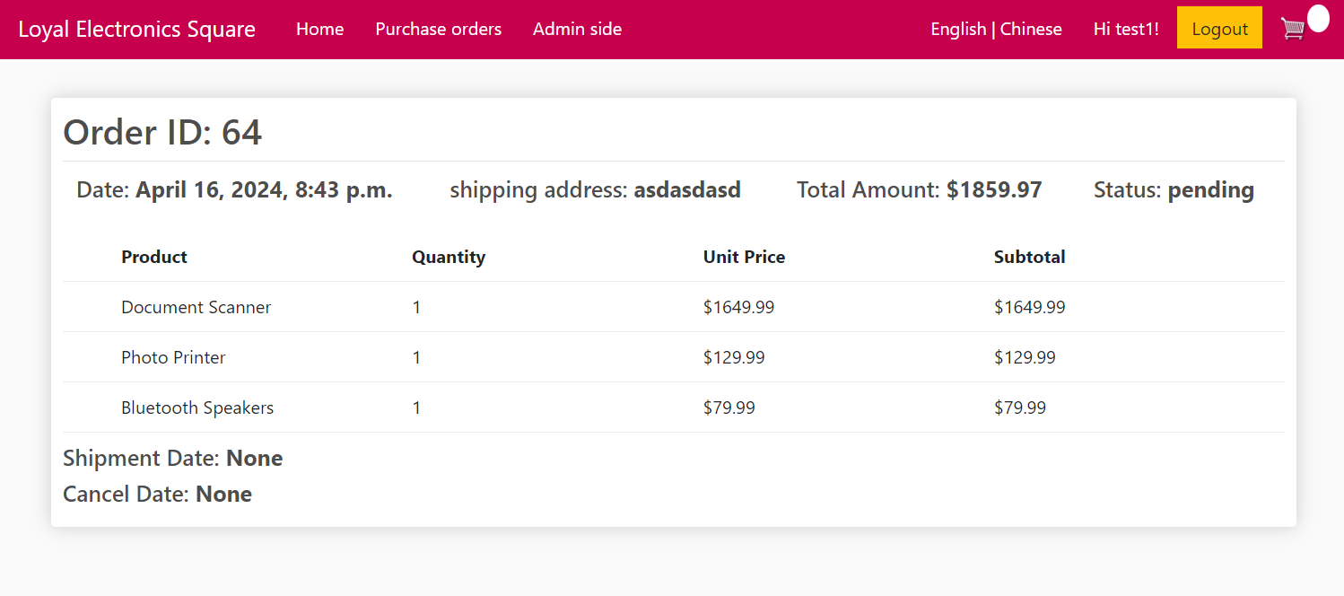
Figure 8: Purchase Order List & Detail Pages
The pictures above are the purchase order page and purchase order detail page of this project.
For purchase order page shows all orders and their date, customer, total price, and status. On the red side, customers can filter orders according to their status. On the blue side, customers can click the link of the order ID to view the order details.
For purchase order detail page shows the order date, shipping address, total amount, and order status, also, it shows all order items and their quantity, unit price and subtotal, total price, and status. On the orange side, there is recorded the shipment date and cancel date.

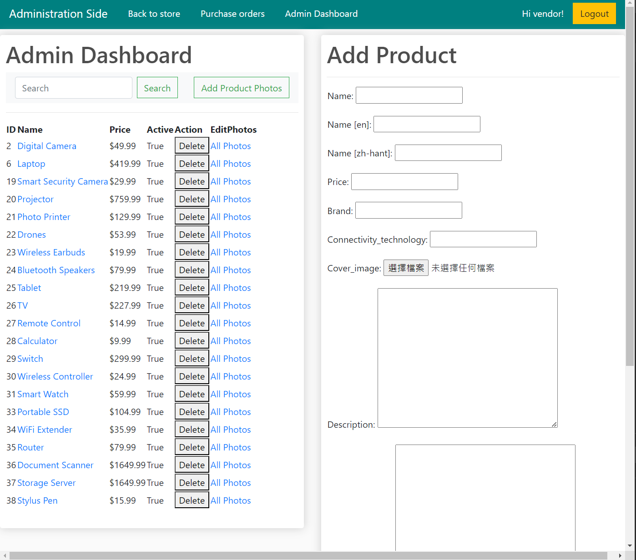
Figure 9: Admin Dashboard Page
The picture above are the admin dashboard page for the vendor of this project, the vendor can manage all products on this page, including adding, editing, and deleting products, also the vendor can manage images of each product. On the red side, there is a search bar to search products and click the button to add images for each product. On the green side, the vendor can click a product name to go to the product edit page for editing the product. On the orange side, the vendor can click one of the rows to edit photos to product images to manage images.

Accessibility
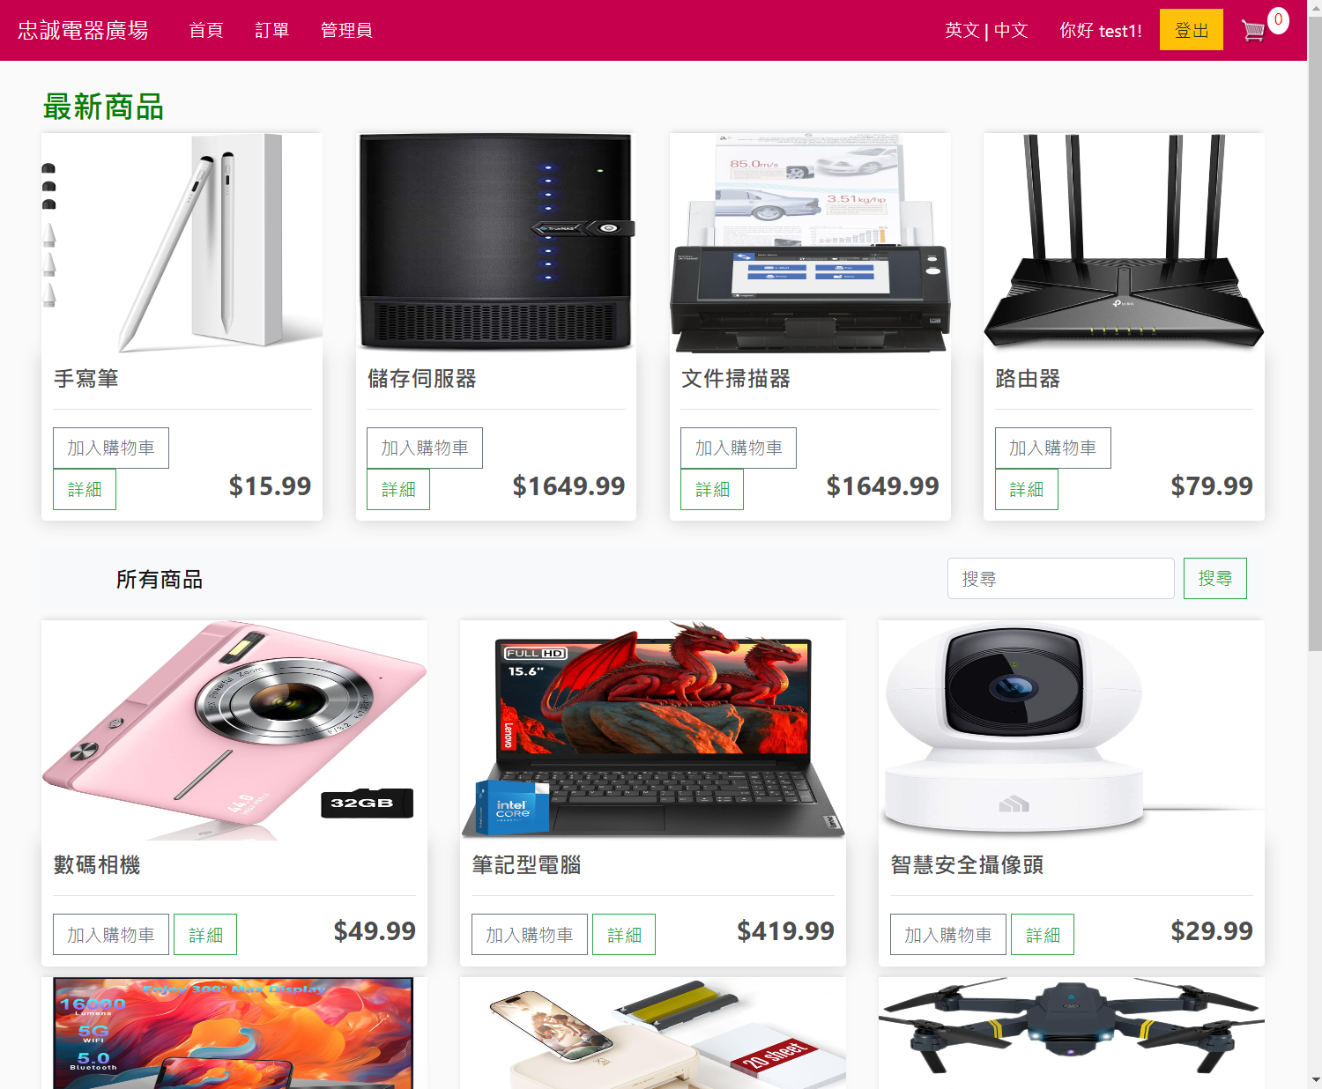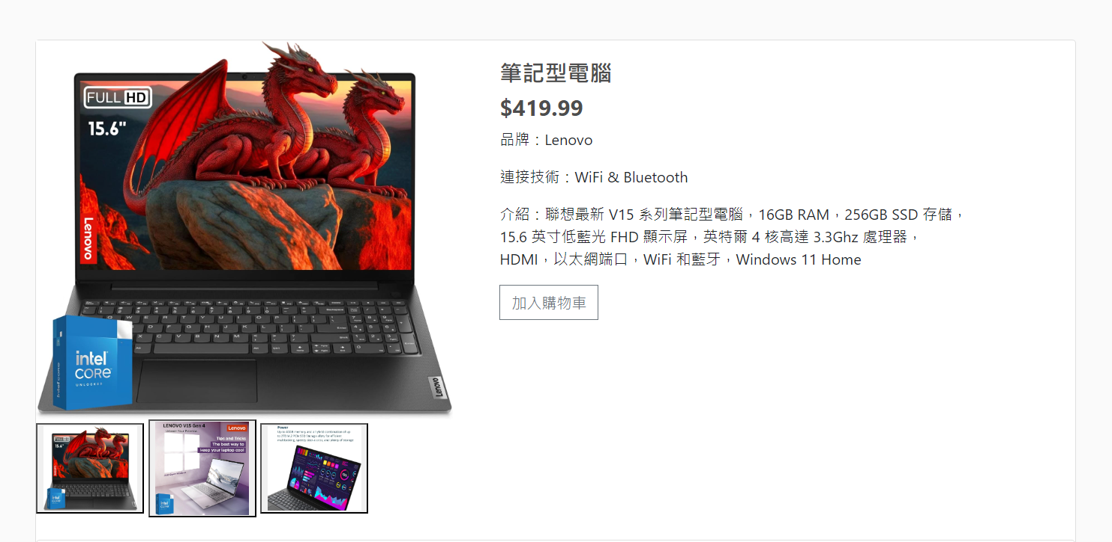
Figure 10: Home & Product Detail Page with i18n
The pictures above are the home & product detail page with i18n of this project. On the black side, the user can click the Chinese link to change the language from the English version to the Chinese version. After clicking the link, the other pages also change to the Chinese version when going to the other page.

Product Recommendations
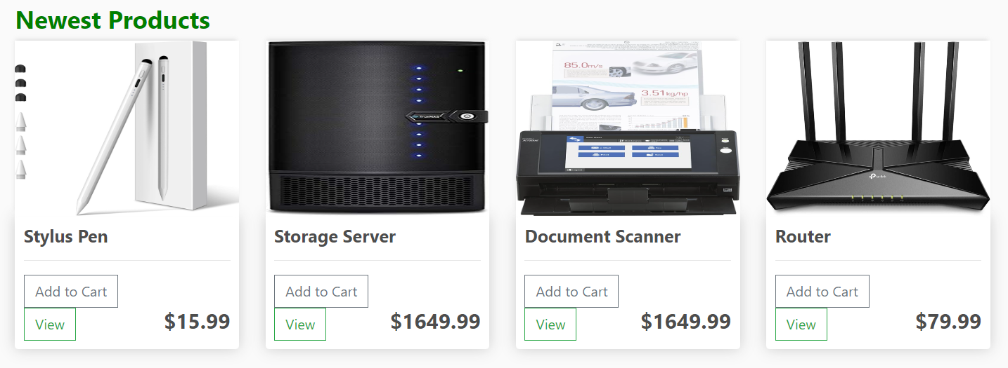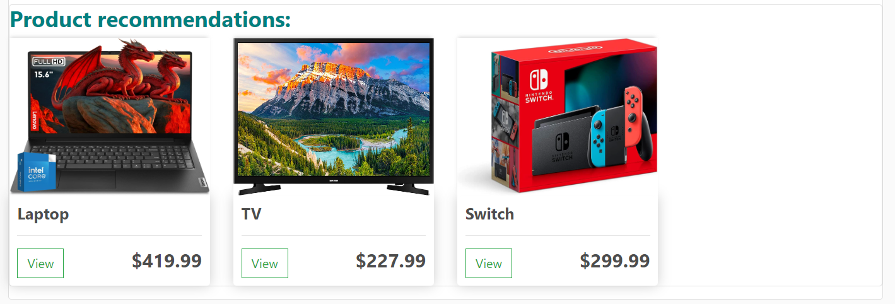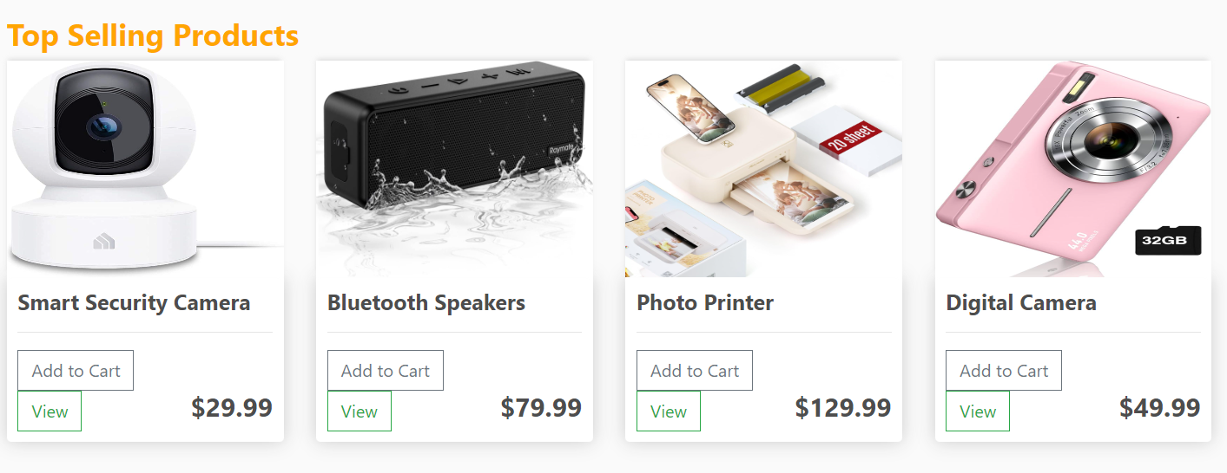
Figure 11: Product Recommendations
The pictures above are the product recommendations of this project, there are 3 types of product recommendations for this project. The newest products, it is shown on the home page, and they are ordered by the latest added products. Product recommendations, it is shown on the product detail page of each product, and it is filtered by the same product brand or same connective technology. For top-selling products, it is shown on the shopping cart page and is ordered by the total quantity sold in order items.

Software Quality
To guarantee a safe and good software, we employed broad testing approach and strong security measures. To illustrate, we conducted an all-inclusive requirement-based testing that covered the essential functionalities and features of the system. We deployed various test data towards proper identification and correction of all issues and insecurities. Moreover, our system had some methods to prevent non-authorized people from accessing user’s information. This concentration on software quality and safety is consistent with our mission of delivering a reliable as well as secure solutions.

Software Verification and Security
Safety of our systems is assured using firm software testing procedures and security.
With this method, we were able to test every significant functionality like user registration, login among others. In addition to that, we have put error checking and data validation for such critical operations as failure intensity computations to identify all possible problems and assure the reliability of the system.
A variety of test scenarios make up our testing effort. We therefore perform a comprehensive testing on login capability by entering both valid and invalid usernames and passwords so that we can ensure that the system behaves as expected. Furthermore, during registration it tests different types of information including correct or wrong email addresses to help detect issues which may arise while validating user input.
We have put in place robust security measures in addition to software verification to safeguard user data and stop illegal access. Secure data encryption technology is used by our system to safeguard private data, including passwords, both during transmission and storage processes. Strict access controls have also been put in place to guarantee that only authorized users may carry out within the system, such accessing personal data and making purchases.
Priority goes to security and software verification. Using a comprehensive testing technique that meets system needs such as registering a user or logging into a system. Moreover, we have put in place appropriate security measures that will ensure that user information is protected while maintaining confidentiality and integrity of the entire system.

Test Case
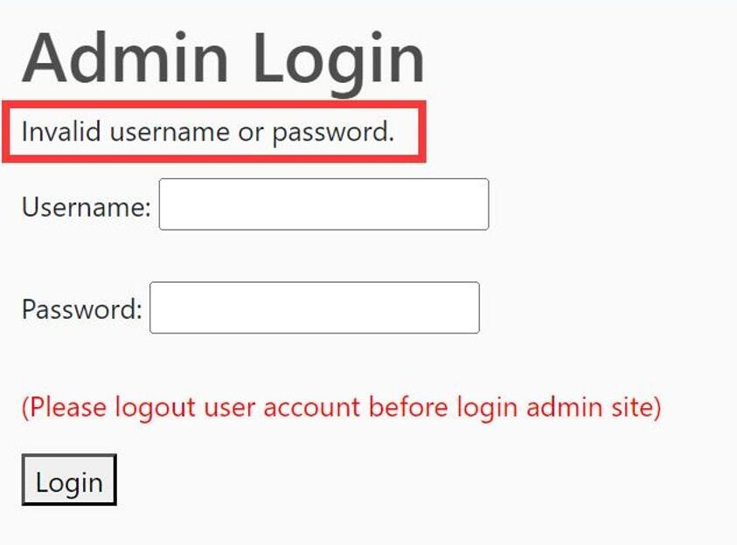
Figure 12: Testing with Login Interface
In the login interface, if the user enters the wrong user and password, a message will be sent to inform the user. And in the exclusive login interface of the management, ordinary users cannot log in.

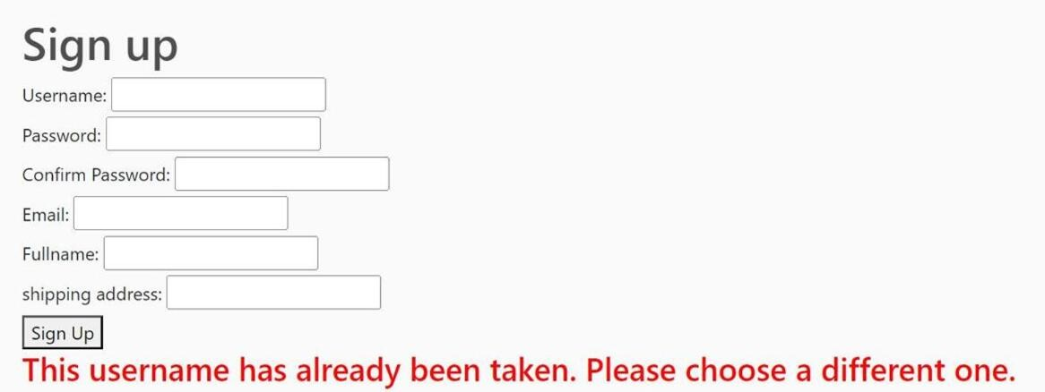
Figure 13: Testing with Register
In the login interface, if the user enters the wrong user and password, a message will be sent to inform the user. And in the exclusive login interface of the management, ordinary users cannot log in.

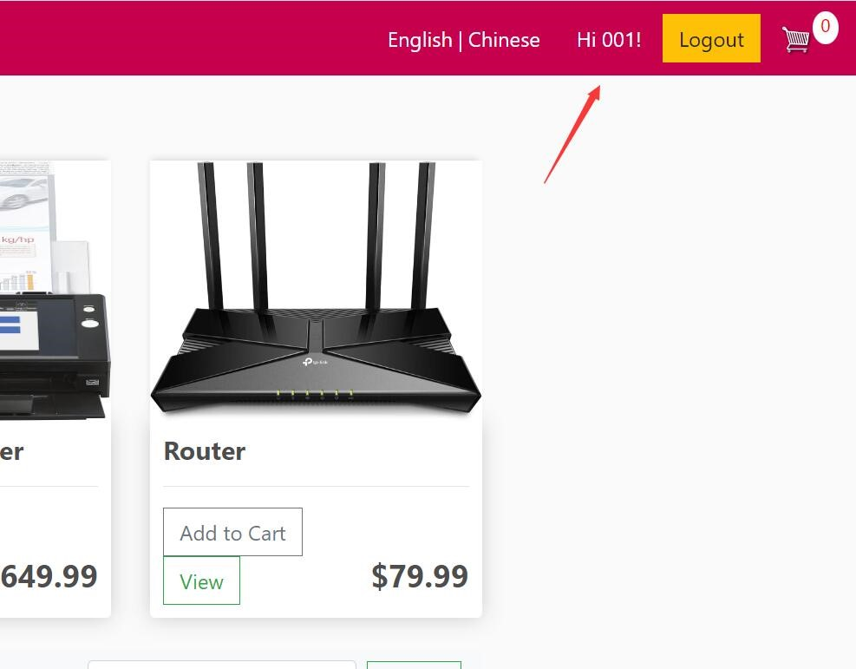
Figure 14: Testing with Login
After the user successfully logs in, the login status will be displayed here.

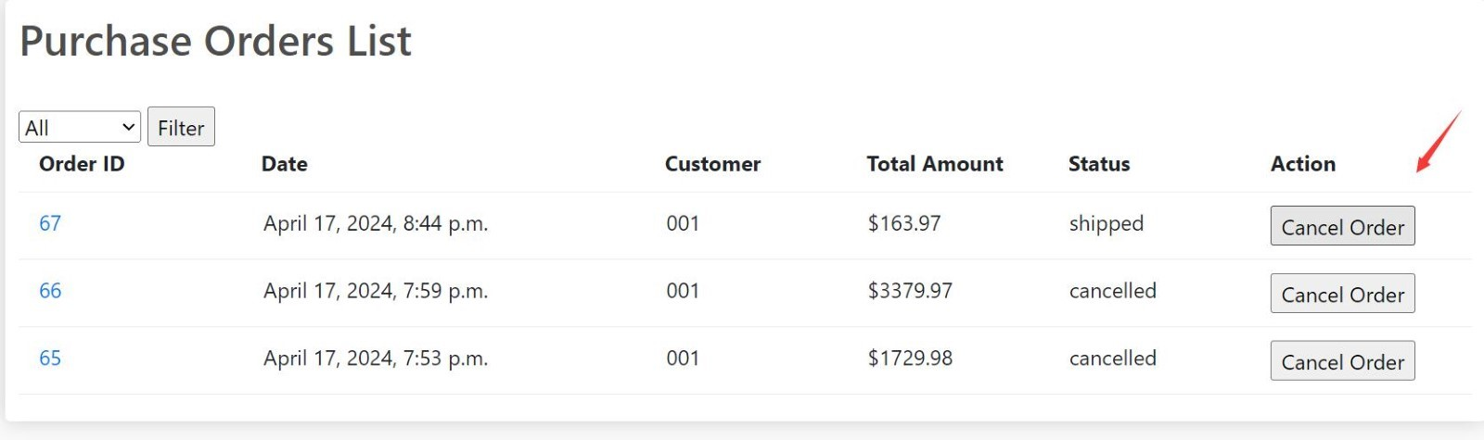
Figure 15: Testing with Order
When the order is in the shipped state, the user cannot cancel the order again.

Project Management
The project management section will introduce and a framework for planning, organizing and executing projects efficiently. It includes several aspects, like setting the project objectives, making a project timetable, recognizing, and handling project dangers, sharing assets and checking progress. The objective of this section is to give project managers and team members the required knowledge and tools needed to complete projects within scope, budget, and schedule. To ensure our success in the implementation of this project, it highlights the significance of effective communication, teamwork as well as flexibility at all levels of the organization till we bring forth our product to the market.

Team Charter
Team Charter is a document created by the team for themselves that outlines how they will work together and covers such things as:
- Project Mission: Our project mission statement reads that we want to make an easy-to-use online shopping mall with various types of commodities, providing a seamless and secure shopping experience.
- Team Purpose: We intend to create and manage a reliable online shop that will serve customers’ needs while satisfying vendors at the same time.
- Team Members, Roles, Responsibilities, and Expertise:
  - Wai Kei Lap: Oversees the project, ensures all aspects are on track, resolves conflicts, and communicates with stakeholders.
  - Leong Chin Hou: Responsible for designing and developing the website. They ensure the site is user-friendly, functional, and visually appealing.
  - Mak Cheok In: Ensures the platform is secure from cyber threats, implements security measures and conducts regular audits.
  - Lee Ling Yu: Tests the website for bugs, ensures the site works as expected, and maintains the quality of the user experience.
- Communication Guidelines: The team will have weekly meetings every Monday at 10 AM via video conference to discuss progress and address any issues. Email will be used for daily updates and urgent matters will be communicated via group chat.
- Decision-making process: Decisions will be made based on consensus. If there’s a disagreement, each team member will present their case and a vote will be held. The majority vote will decide the course of action.

Project Time Management
Activity | Description | Duration | Predecessor
a | Understand and Analyze all Functional requirements | 7
b | Determine Further requirements | 6 | t
c | Planning the project schedule and task allocations | 7
d | work plan writing | 7
e | report writing(chapter 1 &2) | 26 | a,c,d
f | report writing(chapter 3,4&5） | 26 | e,v
g | report writing (chapter 6&7) | 18 | f
h | power presentation and demo-video making | 6 | b,g,u
i | Design and Create data models and database | 6 | a
j | Design and create the individual web pages for the site. | 6 | a
k | Design and Create the product listing feature | 5 | i,j
l | Design and create the customer registration and authentication feature | 5 | j
m | Design and create the product search and detail viewing feature. | 5 | k
n | Design and create the shopping cart and shopping cart management feature. | 5 | l,m
o | Design and create the checkout feature | 5 | n
p | Design and create the feature for listing purchase orders. | 5 | o
q | Design and create the feature for viewing purchase order details. | 5 | p
r | Design and create the feature for product management for vendors. | 5 | q
s | Design and create features for product multiple photos management for vendors. | 5 | r
t | Design and create the feature for purchase order status and status date. | 5 | s
u | Design and Create Further Requirements | 17 | t
v | Ethics form writing | 6 | d
Table 1: Activity List
The picture above exhibits an Activity List with the fields (Activity code, Activity, Duration, and Predecessor). The activities are all the work involved in accomplishing the project.

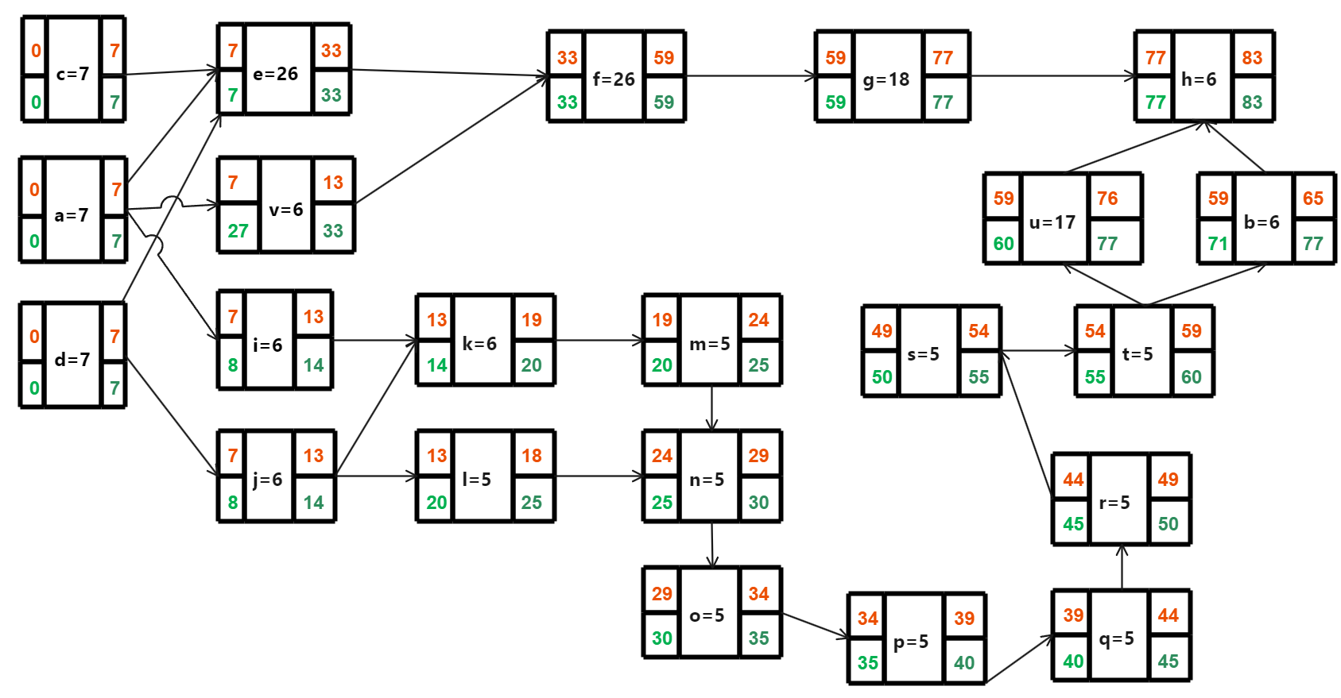
Figure 16: PDM
The picture above is a PDM (Precedence Diagramming Method) based on the Activity List. The PDM specified with the 4 dates (early start, early finish, late start, and late finish) for each activity.

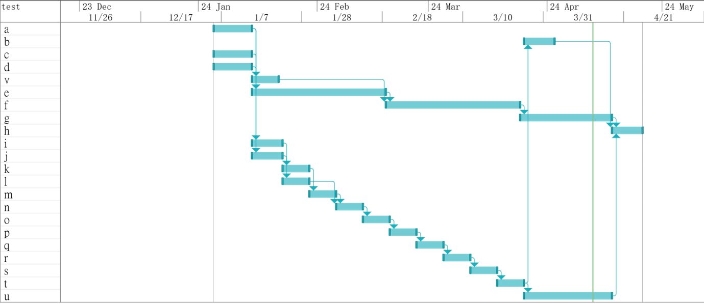
Figure 17: Gantt Chart
The picture above shows the schedule in the form of a Gantt Chart. The left side of the Gantt Chart matches the Activity List.

Project Risk Management
Assess the potential project risks for the project and devise appropriate risk responses to each identified risk. A project risk is the one that poses negative impacts (don’t discuss the positive risks) on the project goals (achieving the target scope, time and cost).
Risk 1: Data Breach
- Description: A data breach risks are a very serious concern for any online platform and could be caused by hacking, insider threats or even accidently releasing data.
- Probability of occurrence: Medium level
- Impact: Loss of customer trust, legal issues and financial losses may arise from such occurrence as a data breach.
- Response: Introduce strong encryption methods for data security, carry out routine security audits and educate your employees on how to manage your information. In addition, prepare yourself with what you will do once the breach has been realized.
Risk 2: Technical Failures
- Description: This risk refers to possible technology challenges within the project like software bugs, hardware malfunctions or third party service delivery difficulties.
- Probability of occurrence: Medium to High level
- Impact: Project delays can occur due to technical failures which increases costs and may affect project outputs’ quality.
- Response: Ensure all hardware as well as software used in the project is constantly updated. For example, when there is a failure in technology it would be great if the team had something like backup systems or other alternatives.
Risk 3: Project Scope Creep
- Description: Scope creep refers to uncontrolled changes or continuous growth in a project’s scope. This can occur when the scope of a project is not properly defined, documented, or controlled.
- Probability of occurrence: High level
- Impact: To manage this risk, it’s important to have a well-defined project scope, involve stakeholders in the planning process, and have a robust change management process in place.

Job Distribution
Member 1: Wai Kei Lap (Overall contribution percentage: 55%)
- Planning the project schedule and task allocations
- Data modelling
- User requirement analysis
- Coding: All functional requirements
- Testing: All functional requirements
- Report writing: chap 3, 4, 6
Member 2: Leong Chin Hou (Overall contribution percentage: 15%)
- Report writing: chap 2, 5
Member 3: Mak Cheok In (Overall contribution percentage: 15%)
- Report writing: chap 1, 7
- Data modelling. (20%)
Member 4: Lee Ling Yu (Overall contribution percentage: 15%)
- User requirement analysis
- Coding: Block A (functions 4,5,7)
- Testing: Block A (functions 1-10)
- Data modelling. (50%)
- Report proof reading

Conclusion
Today, more than ever, it is necessary to ensure that e-commerce platforms protect customers’ personal information and their money. To this end, our platform has implemented strong security measures. This way a secure payment gateway is in business with us so as to guarantee comprehensive safety of customer’s payment details. Regular updates and maintenance work are carried out to enhance the platform's performance and reliability, ensuring the security of customer information.
There are customers who don’t like being interrupted when they are shopping online; for such we have made it possible for them to create an account where they can manage orders, track shipment status or view purchase history at their leisure. Moreover, personalized recommendations are provided to individual clients based on their needs thereby enhancing a customized shopping experience through preferences and previous purchase data. Equally, our website has got sophisticated filtering tools and powerful search engine so that users can quickly find products that fit their specific demands right from the keyword searches or filter parameters. Our ability to search ensures accurate results every time.
In our technologies, we employ a user-focused designing concept with the purpose of offering people-friendly interface, intuitive browsing features and smooth experiences regardless of device used. We have always kept simplicity and ease of use in mind when it comes to designing interfaces that make it easy for users to navigate through our site while making their purchases online. Delivering a professional shopping experience that is also friendly to the user is our major objective if we are to become a leader in online shopping experiences for electronic products. To meet customer’s shopping needs, platform usability, functionality as well as rich features and tools are all about. Our emphasis on high-level security ensures safety of customer personal information and payment data through intuitive navigation and smooth experiences.

Limitations and future works
One important thing in the effective running of an e-commerce website is making sure that product information is updated promptly. Information found in the web about some electronic products and their specifications changes rapidly, as a result out-of-date or wrong product information may lead to clients buying products that don’t meet their needs thus interfering with user experience and contentment. For this reason, there should be a dedicated team to update product information.
Besides, implementing automated update systems can improve efficiency and precision while reducing human errors. By keeping product information updated promptly, an e-commerce website can allow users to find the latest and most correct goods on the market. We can create open-source contributions. Below are the advantages of Open Source. Contributions open-source contributions are very important for all software system’s growth and development. Taking part in open-source communities actively enables developers to collaborate, share knowledge and together improve the functionality and features of projects. This cooperative environment enhances innovative solutions and new approaches towards missing functionalities. On top of that, those who contribute to open source also benefit from opportunities for personal learning and professional development as they learn coding styles, best practices, and new technologies from others. This is a learning experience that helps broaden their skills set as well as gives them wider career prospects.[4] Also, it is essential that one gets actively involved in contributing to Open-Source projects where he/she can build their personal reputation as well as extend their professional networks.[4]

References
[1] Django. (n.d.). Django Project. https://www.djangoproject.com/
[2] Contributors, M. O. J. T. a. B. (n.d.). Bootstrap. https://getbootstrap.com/
[3] SQLite Home page. (n.d.). https://www.sqlite.org/
[4] MPN (2023, Dec 22), The Importance of Open Source Projects: The Story of a Revolution, https://www.linkedin.com/pulse/importance-open-source-projects-story-revolution-mpn-pvt-licpf
[5] Wiegers, K. E., & Beatty, J. (2013). Software Requirements (3rd Edition). Microsoft Press. (Chapter 4: Eliciting requirements), https://www.oreilly.com/library/view/software-requirements-3rd/9780735679658/
[6]Karlsson, J., & Ryan, K. (1997). A cost-value approach for prioritizing requirements. IEEE Software, 14(5), 67-74, https://ieeexplore.ieee.org/document/605933
[7] Research on Software Quality Assurance Based on Software Quality Standards and Technology Management, Peng Shen; Xiaoming Ding; https://ieeexplore.ieee.org/document/8441142
[8] Methodology for Enhancing Software Security During Development Processes, A. R. Shehab Farhan; G. M. Mostafa Mostafa, https://ieeexplore.ieee.org/document/8593135

